Data Warehouse
–
Installation Guide

Table of Contents
1 Introduction 4
2 Physical Layout 5
3 The Installation Components 6
4 Server Requirements 7
4.1 Physical Requirements 7
4.2 Software Requirements 7
4.2.1 Server Requirements 7
4.2.2 Client Requirements 8
5 Installation Procedures 9
5.1 Take OLTP System Offline 9
5.2 FMCDC Components Installation 9
5.3 Data Warehouse Database Installation 10
5.4 SSIS Components Installation 10
5.5 SSIS Preliminary Package Execution 14
5.6 OLAP Database Installation 15
6 Post-Deployment Procedures 17
7 Initial ETL Run 17
7.1 User Configuration 19
7.2 Initial OLAP Cube Processing 20
7.3 Initial Rebuild Indexes 22
7.4 Capture Baseline Configuration and Metrics 22
7.5 Prepare the System For Online Operation 23
7.6 SQL Server Agent Configuration 24
7.7 Daily ETL Job Configuration 25
7.8 Maintenance Job Configuration 26
7.9 Configure the Excel Templates 27
7.10 Take OLTP System Online 27
8 Using the Excel Worksheets 28
9 Appendix A: Version Control 30

Introduction

This document outlines the different steps required to install and configure the components of version 1.0 of the Fuels Manager Data Warehouse solution, as well as the required steps to perform the initial data loading into the Data Warehouse. This Installation Guide applies to a fresh install of the Data Warehouse, i.e. on a server where the Data Warehouse has not previously been installed.

Physical Layout

FMCDC DB Objects

OLTP DB SERVER MACHINE
OLAP SERVER MACHINE

SQL SERVER
(Database Engine)
SQL SERVER
(Analysis Services)
SQL SERVER
(Database Engine)
SSIS Solution

FM
DW DB

FM
OLAP CUBE
FM
OLTP DB

SQL Server Agent Configurations

Pre-Requirements
The following components must be available, prior to the deployment of the Data Warehouse solution:
- SQL Server Enterprise Edition
A SQL Server Enterprise Edition instance must be running on the target machine where the Data Warehouse database and the SSAS database will reside.

- SSIS
SSIS must have been installed on the target machine where the Data Warehouse database and the SSAS database will reside.

- SSAS
SSAS must have been installed on the target machine where the Data Warehouse database and the SSAS database will reside.

- SSRS
SSRS must be running. The Data Warehouse will use the same SSRS server as configured and loaded for FuelsManager.

- Kyubit
Kyubit must have been installed on a Web App server, where IIS resides, with its databases deployed on the same server where the Data Warehouse database and the SSAS database will reside.

The Installation Components

The Fuels Manager Data Warehouse solution is comprised of the following installation components:
- FMCDC Components
FuelsManager Change Data Capture objects. Those are database objects that need to be installed on the existing FuelsManager Enterprise OLTP database. They are responsible to capture on-the-fly data modifications to all the OLTP tables that are covered under the Data Warehouse solution.

- FMCDC Activation Script
SQL Script to activate the FMCDC components.

- FuelsManagerDWDB Database
The FuelsManager data warehouse database. It captures the FuelsManager data in a format appropriate for consumption by the OLAP cube. This is a regular relational database that needs to be hosted on a SQL Server RDBMS.

- SSAS Database
The FuelsManager OLAP Database. This database captures the FuelsManager OLPA cube/s. The OLAP database needs to be hosted on a SQL Server Analysis Services (SSAS) Database Server.

- SSIS Packages
The FuelsManager SSIS packages that control the ETL process that is responsible for both the data extraction from the OLTP database and the update of the OLAP cube.

- SSRS Dashboards
Data Analytics dashboards and reports that provide key business information against the historical data.

- FuelsManager Web Application
The FuelsManager web application, as modified to support the data analytics dashboards.

- Excel Templates
Pre-defined Excel worksheets to cover common OLAP data queries.

- Kyubit Installation Components
OLAP Client tool that provides advanced navigation tools and a set of pre-defined dashboards over the OLAP cube.

Server Requirements

Physical Requirements
<TBD: Will be specified at the end of the QA Testing phase, with the help of Systems Engineering.>

Software Requirements

Server Requirements

SQL Server 2022
- On the target server that will host the data warehouse, run the Microsoft SQL Server 2022 Enterprise Edition (64-bit) installation, with the following components selected:
  - Database Engine Services
  - Analysis Services
  - SQL Server Data Tools
  - Client Tools Connectivity
  - Integration Services
  - Client Tools SDK
  - Management Tools - Complete
  - SQL Client Connectivity SDK

- Make sure the Server Administrator is given administrative rights to the RDBMS and to Analysis Services.

- Make sure SQL Server Agent is configured to run on the SQL Server 2022 instance.

Client Requirements
- Excel For Microsoft Office 365 or any other commercial OLAP client tool (e.g. Power BI)

- Access to the FuelsManager Web application

- Kyubit Enterprise edition

Installation Procedures
Some of the FuelsManagerDW components are installed automatically using the regular FuelsManager installers, while other components have to be installed manually.

The FuelsManagerDW components that have to be installed manually are contained in the following FuelsManager installation sub-folders:
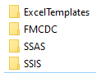

The components need to be installed/configured in the following order:

- FMCDC Components

- Data Warehouse relational database

- SSIS Components

- OLAP database

- SSRS dashboards

Important:
Before initiating the installation, the OLTP System must be taken Offline.
- Make sure that the OLTP database is offline, i.e. it is not receiving any data feed or being updated from any sources.
- Verify that all the fmcdc tables are empty.

FMCDC Components Installation
The FMCDC components are the database objects (triggers, stored procedures, tables, etc.) responsible for capturing Data Changes as they occur in the OLTP system, for the purpose of being later transferred over to the Data Warehouse on the next ETL run.

The FMCDC components are installed as part of the regular FuelsManager DacPac installation on the FuelsManager OLTP system. From SSMS, run a quick check on the FuelsManager OLTP database, to verify that the fmcdc components have been deployed, e.g. look for Stored Procedures under the fmcdc schema.

Data Warehouse Database Installation
The Data Warehouse relational database is deployed as part of the FuelsManager DacPac installation. To update or to deploy the FuelsManager Data Warehouse database for the first time, follow the steps below:

Steps:
- Run the FuelsManager DacPac installer on the target host server for the FuelsManager Data Warehouse database.

- When prompted, confirm the choice to install the Data Warehouse database.

- Set the path where the data warehouse database is to be installed.

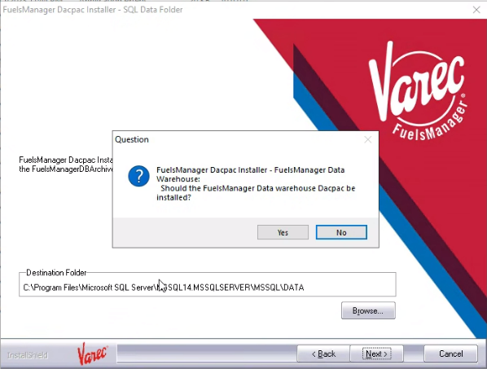

SSIS Components Installation
Steps:
- Initialise Integration Services. If the SSISDB database and SSISDB catalogue have not already been created, open SQL Server Management Studio (RDBMS) and create them as follows:
- In Object Explorer, expand the server node, right-click the Integration Services Catalogs node, and then select Create Catalog.
- Uncheck the Enable This Server As SSIS Scale Out Master.
- Select Enable CLR Integration.
- Select Enable automatic execution of Integration Services stored procedure at SQL Server startup.
- Enter a password, and then click Ok.
The password protects the database master key that is used for encrypting the catalogue data. Save the password in a secure location. It is recommended that you also back up the database master key.
- In the Object Explorer, verify that the SSISDB database is now listed under the Databases node, and the SSISDB catalogue is now listed under Integration Services Catalogs.
- A new SQL Server Agent job, “SSIS Server Maintenance Job”, will automatically be created to support the clean-up and management of the SSIS packages.

- Set up a Catalogue and a Default Environment. A Catalogue is a repository for an SSIS project and its runtime variables. An Environment provides a convenient means of setting all the variables for all the packages of a project under one entity. From SSMS, load the OLTP.SSISDB.CreateCatalogueAndDefaultEnvironment.sql script located under the Installation\SSIS folder. Select the SSISDB as the current database, and run the script.
A new catalogue project, FuelsManagerDWSSISCatalogueProject, should now appear under the Integration Services Catalogs\SSISDB node.
Two folders should appear under the FuelsManagerDWSSISCatalogueProject node: Projects and Environments. Under the Environments folder there should be an Environment with the name DefaultEnvironment.

- Create an additional Environment for manual ETL runs. From SSMS, load the OLTP.SSISDB.CreateAdditionalEnvironment.sql script located under the Installation\SSIS folder. Make sure the @targetEnvironment variable is set to “ManualRunEnvironment". Select the SSISDB as the current database, and run the script.
Under the Environments folder, in addition to the DefaultEnvironment entry under, there should now be a ManualEnviroment folder.
The DefaultEnvironment is reserved for daily, automated ETL runs, whereas the ManualRunEnvironment is intended for the initial data load, and for manual, ad-hoc runs.

- Create an additional Environment for Maintenance package execution. From SSMS, load the OLTP.SSISDB.CreateAdditionalEnvironment.sql script located under the Installation\SSIS folder. Set the @targetEnvironment variable to “MaintenanceEnvironment". Select the SSISDB as the current database, and run the script.
Under the Environments folder, there should now be a MaintenanceEnviroment folder.
The MaintenanceEnvironment is reserved for maintenance related package executions, such as rebuilding the indexes.

- Deploy the SSIS solution. Steps:
- In SQL Server Management Studio, expand the Integration Services > SSISDB node in Object Explorer. Under FuelsManagerDWSSISCatalogueProject, right-click the Projects folder, and then select Deploy Project. The Integration Services Deployment Wizard is loaded.
- On the Introduction page, click Next.
- On the Select Source page, select the Integration Services project deployment file, FuelsManagerDWSSIS.ispac, located under the Installation\SSIS folder.
- If a Warning message appears about failure to decrypt an encrypted XML node, simply click OK. This warning appears because the username used to generate the package is different to the one used to deploy the package.
- On the Select Deployment Target page, leave the default selections unchanged. The SSIS in SQL Server option should be already be selected.
- On the Select Destination page, leave the default selections unchanged. The Server Name should point to SQL Server on which the package is being deployed, and the Path should point to the catalogue path under which the project is being deployed.
- On the Review Your Selections page, review the selections, then click Deploy.
- Close the Integration Services Deployment Wizard.
- Under the Projects node, a new project, FuelsManagerDWSSIS should appear, and under the Packages node, all the packages of the project should be listed.

- Configure the Environment Variables. For both the DefaultEnvironment and the ManualEnvironment, verify each variable, and modify its value as applicable. In particular:
- Set the CMAudit variable connection string to point to the database where the ETL process will be initiated. This should correspond to the Data Warehouse relational database itself.
- Set the CMDestination variable to point to the Data Warehouse relational database.
- Set the CMFMDWSSAS variable to point to the OLAP Analysis Services database.
- Set the CMSource variable to point to the FuelsManager Enterprise OLTP database.
- Set the CMStaging variable to point to the Data Warehouse relational database.
- Enter a valid email address for the EmailSendFrom variable.
- Enter valid email addresses for the EmailSendTo variables.
- Set the EmailServer variable with an SMTP server accessible from the machine.
- Set the ProcessCubeMode variable as ProcessCubeNone
- Set the RebuildIndexes variable as False
- Set the RebuildIndexesOnAllPartitions variable as False

- Link the Environments to the Project. Right-click on the Project, select Configure, and follow the steps below:
- On the References page, add a reference to each Environment that was created earlier. Select the Local Folder versions of the Environments.
- On the Parameters page, select the Connections Managers tab. For each Connection Manager, click on the ellipsis (…) button next to the Connection String parameter, and map the Connection Manager to the Environment Variable as follows:
- AuditCM -> CMAudit
- DestinationOLAPCM -> CMDestination
- SourceFuelsManagerCM -> CMSource
- StagingCM -> CMStaging
- FuelsManagerDWSSASCM -> CMFMDWSSAS
- OLAPCubeCM -> CMFMDWSSAS
- On the Parameters page, select the Parameters tab. Map the following parameters to the Environment Variables as follows:
- Main.dtsx -> ExtractByInventoryDate -> ExtractByInventoryDate
- Main.dtsx -> ProcessCubeMode -> ProcessCubeMode
- Main.dtsx -> ProcessRunDate -> ProcessRunDate
- Main.dtsx -> RebuildIndexes -> RebuildIndexes
- Main.dtsx -> ResetHistoricalStartDates -> ResetHistoricalStartDates
- Main.dtsx -> SkipEntitySourceExtraction -> SkipEntitySourceExtraction
- Main.dtsx -> TransactionBatchExtractionSize -> TransactionBatchExtractionSize
- SendCustomMail.dtsx -> EmailPassword -> EmailPassword
- SendCustomMail.dtsx -> EmailSendCC -> EmailSendCC
- SendCustomMail.dtsx -> EmailSendFrom ->EmailSendFrom
- SendCustomMail.dtsx -> EmailSendFromName -> EmailSendFromName
- SendCustomMail.dtsx -> EmailSendTo -> EmailSendTo
- SendCustomMail.dtsx -> EmailServer -> EmailServer
- SendCustomMail.dtsx -> EmailServerPort -> EmailServerPort
- SendCustomMail.dtsx -> EmailUsername -> EmailUsername
- RebuildDWIndexes.dtsx -> RebuildIndexesOnAllPartitions -> RebuildIndexesOnAllPartitions
- Click OK

- Verify the version of the SSIS solution (See Appendix A: Version Control).

- Test the SSIS deployment. Steps:
- From SSMS, select the FuelsManagerDWDB database, and run the following query:

SELECT auditKey AuditKeyX, ParentAuditKey, PkgName, ProcessNote, SuccessfulProcessingInd, ExecStartDT, ExecStopDT, DATEDIFF(Minute, ExecStartDT, ExecStopDT) ExecTime, *
FROM dbo.tblETLAudit
ORDER BY AuditKey desc

The query should not return any rows if none of the SSIS packages have been executed yet.

- From the under the FuelsManagerDWSSIS\Packages folder, locate and right-click on the SystemCheck.dtsk package, and select Execute. Select the DefaultEnvironment. Click OK.

- When prompted to open the Overview Report, click Yes. The Overview Report on the package execution appears in a separate SSMS tab. Click Refresh to occasionally check on the package execution status. When the package execution completes, its status will show Succeeded. The SystemCheck package is intended to run a quick check on selected elements of the system, including the database connection to the source and destination databases, email notification, and audit logging.

- Once the package is completed, re-run the SQL query on the tblETLAudit table. This time there should be an entry that confirms the SystemCheck execution.
Note: A successful process execution will have a SuccessfulProcessingInd flag of ‘Y’ and an ExecStopDT value.

- Repeat the SystemCheck package execution, for the ManualEnvironment and for the MaintenanceEnvironment.

SSIS Preliminary Package Execution
Before the regular SSIS regular ETL packages can be executed, the data warehouse has to be pre-loaded with look-up data and other metadata to help support the ETL executions.

Steps:
- Verify that the data warehouse database lookup tables, lookup.tblLookup and lookup.tblDispatchGridColumnType, are pre-populated. If not, run the PreloadLookupData.dtsx SSIS package using the DefaultEnvironment.

- Verify that the data warehouse database Date dimension table, dbo.DimDate, is pre-populated. If not, run the PreloadDateDimension.dtsx SSIS package using the DefaultEnvironment.

- Verify that the data warehouse database Time dimension table, dbo.DimTime, is pre-populated. If not, run the PreloadTimeDimension.dtsx SSIS package using the DefaultEnvironment.

- Verify that the data warehouse dimension tables, e.g dbo.DimEquipment, are pre-populated with a dummy record. If not, run the PreloadDummyEntries.dtsx SSIS package using the DefaultEnvironment.

OLAP Database Installation
Steps:
- Login to the machine using a user who has been configured, during the SQL Server 2022 installation, to have Analysis Services administrative rights.

- Open a new instance of SQL Server 2022 SSMS. Make sure to select Analysis Services as the Server Type. Select the target server for the Data Warehouse.

- From SSMS, right-click on the server node -> Properties -> General, and verify that the target location for the DataDir property of the server is set to the dedicated drive and folder for the FuelsManager OLAP database, if not, change it accordingly.

- From SSMS, click on File -> Open, and select the XMLA file found under the Installation\SSAS folder.

- In the XMLA file, locate the DataSource tag. This defines the relational Data Warehouse database source for the OLAP cube.
Change the ConnectionString, Account, and Password tags according to the connection parameters for the Data Warehouse database that was restored and configured in the previous section. Make sure the selected account has access to the OLAP relational database.

- Execute (F5) the XMLA script. Make sure that there are no errors.
Note: Check the query results window carefully. Errors might be thrown even if the query returns “Query executed successfully”.

- Refresh the Object Explorer window and verify that a new OLAP database, FuelsManagerDWSSAS, is now listed under the server.

- Verify the version of the OLAP database (See Appendix A: Version Control).

- From the Object Explorer window, right click on the server name and select Properties. Select the General tab, then check “Show Advanced (All) Properties”. Adjust the ExternalCommandTimeout setting to 36000 seconds. The default value is 3600 seconds.

- Right-click on the FuelsManagerDWSSAS database, and select Process -> OK, to process the cube. This should only take a couple of minutes since at this stage the data warehouse is empty, except for the dummy records.

- Run the MDX query below to test the SSAS deployment.
Note: This is just to check for deployment/configuration errors. The query will not return any data at this stage, other than the dummy records, because no data has been loaded yet in the Data Warehouse database.

SELECT [Measures].[GrossQuantitySI] ON COLUMNS,
NONEmpty([Inventory Date].[Date Hierarchy].[Calendar Year]) ON ROWS
FROM [Fuels Manager DW]

SSRS Dashboards Installation
The SSRS Data Analytics Dashboards are deployed as part of the FuelsManager Report installation. To deploy the FuelsManager SSRS Data Analytics Dashboards for the first time, or to update and existing installation, follow the steps below:

Steps:
- Run the FuelsManager Report installer on the target host server where the FuelsManager Reporting Services server is running.

- When prompted, confirm the choice to deploy the Data Analytics dashboards.

- When prompted, enter the data source information for the data warehouse database.

- When prompted, enter the data source information for the OLAP database.

- The SSRS Data Analytics Dashboards will be uploaded onto the Reporting Services server under the Standard Reports folder, together with the other FuelsManager SSRS reports.

FuelsManager Data Analytics Dashboards Set Up
After the SSRS Data Analytics dashboards are deployed on the SSRS server, they need to be added to the FuelsManager report list, just like with a regular report.

- If the FuelsManager web application is not already configured for reports on the target SSRS server, do so following the regular FuelsManager Report configuration steps.

- From Administration -> System Settings, note down the Windows account name configured as the Report Server User Name. From SSAS, make sure that this Windows account is listed as an SSAS Administrator.
Note: This configuration step is required for the MVP release, where all the SSRS OLAP dashboards run under the same Windows Account, the account configured as the Report Server User Name.

- Using the FMKeyRead.exe utility, verify that the FuelsManager instance is licensed for:
- Data Warehouse
- Data Analytics

- From the FuelsManager web application, verify that the current user account, which will be used to configure the OLAP SSRS dashboards in FuelsManager, has the View Data Analytics permission.

- From the FuelsManager web application, from the upper level sitegroup where the regular FuelsManager reports are defined, e.g. Varec, go to Configuration -> Report Group. Create the following Report Groups:
- DW Dashboards
- DW Reports

- From the upper level sitegroup where the regular FuelsManager reports are defined, e.g. Varec, go to Configuration -> Report Assignment.

- On the Report Assignment page, click on Add Report. On the Report Detail Configuration page, configure the Accounting Dashboard as follows:
- ReportName: Accounting Dashboard
- Report Path: DW_AccountingDashboard
- Assigned Group: DW Dashboards
- Data Warehouse Report checkbox: checked
- Assigned User Groups: Assign the dashboard to user groups as necessary

- On the Report Assignment page, click on Add Report. On the Report Detail Configuration page, configure the Terminal Automation Dashboard as follows:
- ReportName: Terminal Automation
- Report Path: DW_TerminalAutomationDashboard
- Assigned Group: DW Dashboards
- Data Warehouse Report checkbox: checked
- Assigned User Groups: Assign the dashboard to user groups as necessary

- On the Report Assignment page, click on Add Report. On the Report Detail Configuration page, configure the Gross Quantity Matrix as follows:
- ReportName: Gross Quantity Matrix
- Report Path: DW_GrossQuantityMatrix
- Assigned Group: DW Reports
- Data Warehouse Report checkbox: checked
- Assigned User Groups: Assign the dashboard to user groups as necessary

- From the menu click on Data Analytics. The data analytics dashboards configured above should be listed under the Data Analytics menu.
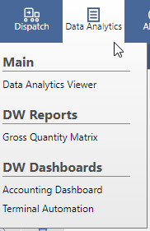

Kyubit Components Installation
Follow the Kyubit Component Installation steps.

Kyubit Installation

Kyubit Pre-Installation Requirements
Steps:
- Create the following Active Directory users:
  - FMBISystemUser: to be used to install and configure Kyubit for AD
This user must have enough permissions on the Data Warehouse database server to create new databases.
This user must have enough permissions on the Web App server to add new App Pools and new Web Applications.
The user must have enough permissions to create and execute windows services on the Web app server.

Kyubit Installation
Steps:
- Using the FMBISystemUser AD account, login to the target Web application server where Kyubit will be hosted, and run the Kyubit Setup.exe installation.
- Specify the database server that hosts the data warehouse database as the host server for the Kyubit databases
- Specify the FMBISystemUser AD account as the Kyubit Intelligence Windows Account to be used by Kyubit.
- After installation, to launch Kyubit, go to Start Menu -> Kyubit -> Kyubit Business Intelligence

Kyubit Post-Installation Configuration
Steps:
- Create the following Active Directory users:
  - FMBISystemUser: to be used to configure Kyubit for AD
  - FMBIReadOnlyUser: Account to test the visitor user access to Kyubit
  - FMBIReadWriteUser: Account to test the creator user access to Kyubit
  - FMBIAdminUser: Account with admin access to Kyubit, to be used by a Varec system administrator

- Create the following Active Directory user groups:
  - FMBIReadOnlyUsers: users to be granted Visitor Kyubit role only. Add the FMBIReadOnlyUser user to this group.
  - FMBIReadWriteUsers: users to be granted Creator Kyubit role. Add the FMBIReadWriteUser user to this group.
  - FMBIAdminUsers: users to be granted Administrator Kyubit role. Add the FMBIAdminUser user to this group.

- Configure Kyubit for Active Directory access using the FMBISystemUser AD user account.

- Create all the necessary Kyubit user and usergroup accounts from the Active Directory user and usergroup accounts. Assign them the appropriate role.

- Configure Kyubit for white-labelling
  - Open the Kyubit Business Intelligence web.config (C:\Program Files\Kyubit\BusinessIntelligence\web.config).
Set the value of the WhiteLabelActive key to 1.
Set the value of the HideTutorials key to 1.
Set the value of the OnlyAdminCubes key to 1.
Set the value of the AnalyticModelsDisabled key to 1.
Set the value of the HomePageConfig key to blank.
Change the SplashText1, SplashText2, FooterText, and AppMsgHeader text accordingly.
  - Go to the folder C:\Program Files\Kyubit\BusinessIntelligence\WhiteLabel and replace the images as necessary.
  - From the Home Page Side Content form, change the selection from Tutorials and Features Overview to Text(HTML) and create a new Help tab to add information on the Data Warehouse solution version number and a link to the FuelsManager help files.
  - Open the Kyubit Subscription Windows Service Config file (C:\Program Files\Kyubit\SubscriptionService\Kyubit.SubscriptionService.exe.config) and white label on the KPI Alert text messages. Restart the Kyubit Subscription Windows service.

Kyubit Object Deployment
Steps:
- From Kyubit, manually create the folder structure below:
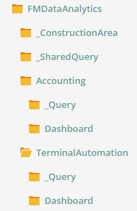

- Give the FMBIAdminUsers usergroup read/write access to all the folders.

- Give the FMBIReadWriteUsers usergroup read/write access to the folders:
  - _SharedQuery
  - Accounting (including the subfolders)
  - TerminalAutomation (including the subfolders)

- Give the FMBIReadOnlyUsers usergroup read-only access to the following folders:
  - _SharedQuery
  - Accounting (including the subfolders)
  - TerminalAutomation (including the subfolders)

- From Kyubit, manually create the following data sources:
  - FuelsManagerDW: Data Source to the FuelsManagerDW OLAP cube
  - FuelsManagerDWClient: Data Source to the FuelsManagerDWClient Perspective of the FuelsMAnagerDW OLAP cube
  - FuelsManagerDWPrototype: Data Source to the FuelsManagerDWPrototype OLAP Cube

- For each datasource, define the Time Intelligence on all the applicable date hierarchies.

- Give the FMBIAdminUsers usergroup read/write access to all the data sources.
Give the FMBIReadWriteUsers usergroup and the FMBIReadOnlyUsers usergroup read-only access to the FuelsManagerDWClient data source.

- Using the FMBIReadOnlyUser, FMBIReadWriteUser, and FMBIAdminUser AD user accounts, verify access and permissions to Kyubit.

- With the Overwrite Existing checkbox unchecked, import the Kyubit objects as follows:
Kyubit File | Target Folder
ConstructionArea_Analysis.xml | _ConstructionArea
Shared_Analysis.xml | _SharedQuery
Accounting_Analysis.xml | Accounting\_Query
TerminalAutomation_Analysis.xml | Terminal Automation\_Query
Prototype_Dashboard.xml | _ConstructionArea
Accounting_Dashboard.xml | Accounting\Dashboard
TerminalAutomaton_Dashboard.xml | Terminal Automation\Dashboard
ConstructionArea_KPI.xml | KPIs

- For each Analysis and Dashboard that has a Site filter, put the Analysis/Dashboard in Design mode, then set the Site filter to the top-level client Site/SiteGroup (e.g. Citgo), then save the Analysis/Dashboard.

- Set up and verify Subscriptions as necessary

Post-Deployment Operations
After the various components of the Data Warehouse solution have been properly installed, and validated wherever possible, the next step is to perform the necessary operations to hydrate the data warehouse and to configure it for regular usage.

In its normal life-cycle, the Data Warehouse solution is intended to be fully automated, but the initial data loading requires a few manual interventions.

Initial ETL Run
As a result of the large amount of data cleansing and data processing that are involved in preparing the data for the Data Warehouse, depending on the number of transactions in the source OLTP database, the initial ETL run can be a very resource-intensive and time-consuming exercise. E.g. loading and processing of 9 million records can take 36 hours or more to run, depending of the server machine.

Steps:
- Make sure that the OLTP database is offline, i.e. it is not receiving any data feed or update from any sources.

- Verify that all the fmcdc data capture tables are empty, if not truncate the fmcdc tables.

- Set Recovery Model to Simple on the Data Warehouse Database.
From SSMS, in Object Explorer, right-click on the FuelsManagerDWDB database, and select Properties. Select Options. Change the Recovery to Simple.
Initially there is no transaction data in the database, and there is no reason to turn on full SQL Server logging, since a failure in the ETL process will require a full re-run of the initial data loading.

- Set the Recovery Model to Simple on the OLTP Database.
Provided the OLTP database is being temporarily taken offline during the initial ETL run, and is not being used other than by the Data Warehouse ETL, then we can also set the Recovery Model to Simple on the OLTP database. From SSMS, in Object Explorer, right-click on the FuelsManager database, and select Properties. Select Options. Change the Recovery to Simple.

- Disable SQL Server Agent Job for the ETL
If a previous SQL Agent Job was defined to automatically execute the Data Warehouse ETL process, disable that job.

- Set the variables for the Manual Run. Steps:
- From SSMS, in Object Explorer, expand the Integration Services Catalogs\SSISDB\FuelsManagerDWSSISCatalogueProject\Environments node. Right-click on the ManualRunEnvironment node and select Properties.
- Make sure that the ProcessCubeMode is set to ProcesCubeNone, the ProcessRunDate reads 1/1/1910, and the TransactionBatchExtractionSize is set at 200000.

Note:
The ProcessRunDate controls the range of data extracted. A ProcessRunDate of 1/1/1900 corresponds to an extraction that is limited only to the data that have been captured in the CDC tables, i.e. usually it will correspond to the data for the day only. This should be the setting for the DefaultEnvironment. By changing the ProcessRunDate to 1/1/1910 we are forcing the ETL process to fetch data directly from the Source tables for UpdatedDate going as far back as 1/1/1910.
Trying to process all the transaction records from the source tables on an initial load in a single batch could cause the system to run out of resources and to crash. The TransactionBatchExtractionSize controls the number of transaction records extracted and processed in a batch, and helps process the transaction in smaller segments. The TransactionBatchExtractionSize is only applicable for the case where the ProcessDate is greater than 1/1/1900. When the ProcessDate is 1/1/1900 the TransactionBatchExtractionSize is ignored and all the transactions are extracted and processed in a single batch.

- Extract, Process, and Load the Complete Set of Transactions from the OLTP database. Steps:
- From SSMS, in Object Explorer, expand the Integration Services Catalogs\SSISDB\FuelsManagerDWSSISCatalogueProject\Packages node. Right-click on the Main.dtsx package and select Execute. Select the ManualRunEnvironment and click OK.
- When prompted to open Overview Report, click Yes. The Overview Report on the package execution appears in a separate SSMS tab. Click Refresh to occasionally check on the package execution status. When the package execution completes, its status will show Succeeded.
- The initial execution of the Main.dtsx package on a manual run can take a very long time, e.g. The initial ETL run over 15 million transactions can take up to 72 hours. In addition to the Overview Report window, the progress of the ETL execution can be followed from the dbo.tblETLAudit table, using the SQL query listed earlier.

- Process Errors.
ETL process failures are recorded in multiple ways:
- By Email notification
- In the Integration Services Overview Report
- In the FuelsManagerDWDB.dbo.tblETLAudit table
- In the Event Viewer
- In the SQL Server Agent Job History
Any process failure will need to be investigated. Process failures are generally due to either data discrepancies (requires correction to the data) or to system resource failure (requires more resources to be allocated to the server).

- Back up the database.
Make a full back up of the FuelsManagerDWDB Data Warehouse database.

- Set Recovery Model to back to Full on the Data Warehouse database.
From SSMS, in Object Explorer, right-click on the FuelsManagerDWDB database, and select Properties. Select Options. Change the Recovery to Full. (Note: The decision of whether to set the Recovery Model of the Data warehouse database to Full or not would be a DBA decision).

- Set Recovery Model to back to Full on the OLTP database.
If the Recovery Model on the OLTP database was modified for the purpose of the initial ETL run, then reset it back to its previous value. From SSMS, in Object Explorer, right-click on the FuelsManagerDWDB database, and select Properties. Select Options. Change the Recovery to Full.

User Configuration
Access to the cube is controlled by SSAS through Windows Security. In addition FuelsManager further restricts access to Company and Site data based on user permissions. This part of the set-up is concerned with configuring those user security parameters.

Steps:
- Identify the set of Windows Logins that need access to the Cube
From SSMS for Analysis Services, in Object Explorer, right-click on Databases\FuelsManagerDWSSAS\Roles\DynamicSecurityRole and select Properties. Click on Membership. Add the Windows Login of each user that needs access to the cube.

- Add the same Windows Logins to the DimWindowsLoginUser Table.
From SSMS for RDBMS, open a new SQL query window against the FuelsManagerDWDB database. Insert a new record in table dbo.DimWindowsLoginUser for each Windows Login that was added to the Security Role Membership.
E.g.

INSERT INTO dbo.DimWindowsLoginUser
(WindowsLoginUserId)
VALUES
('leidos-corp\AUser')

- Map the Windows Logins to the FuelsManager User Accounts.
From SSMS for RDBMS, open a new SQL query window against the FuelsManagerDWDB database. Add entries in the [dbo].[FactWindowsLoginUserToFMUser] table to map the dbo.DimWindowsLoginUser.SKey key values to the DimFMUser.SKey key values.
E.g.

INSERT INTO FactWindowsLoginUserToFMUser
(WindowsLoginUserSKey,FMUserSKey)
VALUES (1, 1)

After being mapped to an FMUser, the Windows User will have the same Site and Company mappings as the FMUser. To verify the current Site and Company for a given FMUser, run queries against the following tables:
- dbo.FactFMUserToSite
- dbo.FactFMUserToCompany

Note: A single Windows Login can be mapped to multiple or all FM Users.

- From Kyubit, create a Kyubit user for each Windows user added to the OLAP cube.
Make sure the Kyubit users are created under the right Kyubit UserGroup (FMBIReadOnlyUsers, FMBIReadWriteUsers, FMBIAdminUsers).

Initial OLAP Cube Processing
Now that the Data Warehouse database has been populated we can process the cube. This operation could take a few hours. Steps:

- Set the variables for the DefaultEnvironment. Steps:
- From SSMS, in Object Explorer, expand the Integration Services Catalogs\SSISDB\FuelsManagerDWSSISCatalogueProject\Environments node. Right-click on the DefaultEnvironment node and select Properties.
- Make sure that the ProcessCubeMode is set to ProcesCubeAll, the ProcessRunDate reads 1/1/1900, and the TransactionBatchExtractionSize is set at 0
- For this first cube processing exercise, set the RebuildIndexes to False, and the RebuildIndexesOnAllPartition to False

- Run the full ETL process using the Default Environment. Steps:
- From SSMS, in Object Explorer, expand the Integration Services Catalogs\SSISDB\FuelsManagerDWSSISCatalogueProject\Packages node. Right-click on the Main.dtsx package and select Execute. Select the DefaultEnvironment and click OK.
- When prompted to open Overview Report, click Yes. The Overview Report on the package execution appears in a separate SSMS tab. Click Refresh to occasionally check on the package execution status. When the package execution completes, its status will show Succeeded.
- Provided little or no changes have been recorded against the OLTP Enterprise database since the initial run of the ETL process, this ETL execution should be limited for the most part to the cube processing only, which should only take a few hours to complete. In addition to the Overview Report window, the progress of the ETL execution can be followed from the dbo.tblETLAudit table, using the SQL query listed earlier.

- From SSMS For Analysis Services, run the MDX query below to verify the Cube processing.
Note: The query will show aggregated Gross Quantity values for each Calendar Year for which data is available.

SELECT [Measures].[Gross Quantity SI] ON COLUMNS,
NONEmpty([Inventory Date].[Date Hierarchy].[Calendar Year]) ON ROWS
FROM [Fuels Manager DW]

Initial Rebuild Indexes
Now that the data warehouse has been fully populated, and the OLTP cube has successfully been processed, we can proceed to fully rebuild the data warehouse indexes to help improve the efficiency of the ETL process. This operation could take a few hours. Steps:

- Set the variables for the MaintenanceEnvironment. Steps:
- From SSMS, in Object Explorer, expand the Integration Services Catalogs\SSISDB\FuelsManagerDWSSISCatalogueProject\Environments node. Right-click on the MaintenanceEnvironment node and select Properties.
- Set the RebuildIndexesOnAllPartition to True

- Rebuild the indexes on all partitions using the Default Environment. Steps:
- From SSMS, in Object Explorer, expand the Integration Services Catalogs\SSISDB\FuelsManagerDWSSISCatalogueProject\Packages node. Right-click on the RebuildDW.dtsx package and select Execute. Select the MaintenanceRunEnvironment and click OK.
- When prompted to open Overview Report, click Yes. The Overview Report on the package execution appears in a separate SSMS tab. Click Refresh to occasionally check on the package execution status. When the package execution completes, its status will show Succeeded.
- This operation rebuilds the indexes on all the partitions and can take several hours to complete. In addition to the Overview Report window, the progress of the ETL execution can be followed from the dbo.tblETLAudit table, using the SQL query listed earlier.

Capture Baseline Configuration and Metrics
Capture the following baseline configurations and metrics on the system:
- Server hardware specifications
- Server software configurations
- OLTP SQL Server configuration
- Data Warehouse SQL Server configuration
- FuelsManager OLTP DB Size
- FuelsManager Data Warehouse DB size
- SSAS DB Size
- FuelsManager OLTP Transaction count
- Dbo.FactTransaction partition distribution, count and size
- Initial ETL Execution Time
- First (empty) Daily ETL Execution Time
- Execution Time of the first full Rebuild Indexes (all partitions).

Prepare the System For Online Operation
In preparation to taking the data warehouse system online, execute the following verification and configuration steps:
- Set the DefaultEnvironment for daily runs. Steps
- From SSMS, in Object Explorer, expand the Integration Services Catalogs\SSISDB\FuelsManagerDWSSISCatalogueProject\Environments node. Right-click on the DefaultEnvironment node and select Properties.
- Make sure that the ProcessCubeMode is set to ProcesCubeAll, the ProcessRunDate reads 1/1/1900, and the TransactionBatchExtractionSize is set at 0
- Set the RebuildIndexes to True, and the RebuildIndexesOnAllPartition to False. This restricts the RebuildIndexes exercise on the dbo.FactTransaction table to only the last active partition using a sampling algorithm.

- Set the MaintenanceEnvironment for maintenance package execution. Steps
- From SSMS, in Object Explorer, expand the Integration Services Catalogs\SSISDB\FuelsManagerDWSSISCatalogueProject\Environments node. Right-click on the MaintenanceEnvironment node and select Properties.
- Set the RebuildIndexesOnAllPartition variable to True.
- Leave the other variables that are not used by the RebuildDWIndexes.dtsx package to their default values: Leave the ProcessCubeMode to ProcesCubeNone, the ProcessRunDate to 1/1/1900, the TransactionBatchExtractionSize to 0, and the RebuildIndexes to False.

- Create a new SQL Server Agent Job to execute the Main.dtsx package daily (see Daily ETL Job Configuration).

- Create a new SQL Server Agent Job to execute the RebuildDW.dtsx package for full rebuild indexes on all partitions (see Maintenance Job Configuration).

SQL Server Agent Configuration
The Data Warehouse solution is designed to operate in a fully automated mode. The ETL automation is supported through the help of SQL Server Agent.

Create a New Credential
- Start SQL Server Agent.
From SSMS, in Object Explorer, right-click on SQL Server Agent and select Start if it has not already been started.

- Create a Credential to Run the SQL Server Agent Job
- From SSMS, in Object Explorer, right-click on Security\Credential and select New Credential.
- Set the Credential Name as FuelsManagerDWCredential.
- Set the identity to that of a user who has administrative privileges on the SQL Server Analysis Services instance.
- Enter the Password.
- Click OK.

Create a Proxy to Run the SQL Server Agent Job
- From SSMS, in Object Explorer, right-click on SQL Server Agent\Proxies and select New Proxy.
- In the General tab, set the Proxy Name as FuelsManagerDWProxy.
- In the General tab, set the Credential Name as that of the Credential created earlier, FuelsManagerDWCredential.
- In the General tab, select the checkbox for the following subsystems:
  - SQL Server Analysis Services Command
  - SQL Server Analysis Services Query
  - SQL Server Integration Services Package
- In the Principals tab, add a user who has administrative privileges on the SQL Server Analysis Services instance.
- Click OK.
- Verify that the proxy has been created under SQL Server Agent -> Proxies -> SSIS Package Execution

Daily ETL Job Configuration
A SQL Server Agent job is required to automate the execution of the data warehouse ETL on a pre-determined schedule. Steps:
- Add a New Job for the Daily ETL Process
- From SSMS, in Object Explorer, expand the SQL Server Agent node. Right-click on Jobs, and select New Job.
- In the General tab, set the Job Name as FuelsManager Data Warehouse Daily ETL.
- In the Steps tab, click on New.
  - On the General tab, set the Step Name as Main Package.
  - On the General tab, set the Type as SQL Server Integration Services Package.
  - On the General tab, set the Run As property to the Proxy created earlier, FuelsManagerDWProxy.
  - On the General tab, on the Package tab, leave the Package source as SSIS Catalog.
  - On the General tab, on the Package tab, set the Server as the name of the server where the SSIS solution was deployed.
  - On the General tab, on the Package tab, set the Package as Main.dtsx.
  - On the General tab, on the Configuration tab, set the Environment as DefaultEnvironment.
  - Click OK to save the Step.
- In the Schedules tab, click on New.
  - Set the Schedule Name as Daily Schedule.
  - Set the Frequency as Daily.
  - Set the time for the Occurs Once At property, e.g. 1:00:00 AM. Make sure that the scheduled time does not clash with the SSIS Server Maintenance Job or any other jobs scheduled on the server.
  - Click OK to save the Schedule.
- Click OK to save the new Job.

- Test the new Job
Steps:
- Change the time for the schedule of the FuelsManager Data Warehouse Daily ETL job, so that it runs at the appropriate time for testing, e.g. in a few minutes.
- Verify that the job ran at the correct time.
- Verify from table tblETLAudit that the ETL process executed successfully.
Note: A successful process execution will have a SuccessfulProcessingInd flag of ‘Y’ and an ExecStopDT value.
- Reset the time for the schedule of the FuelsManager Data Warehouse Daily ETL job appropriately.

Maintenance Job Configuration
A SQL Server Agent job is required to automate the execution of the RebuildDWIndexes.dtsx package for full rebuild indexes on all partitions, on a pre-determined schedule. Steps:
- Add a New Job for the Daily ETL Process
- From SSMS, in Object Explorer, expand the SQL Server Agent node. Right-click on Jobs, and select New Job.
- In the General tab, set the Job Name as FuelsManager Data Warehouse Maintenance.
- In the Steps tab, click on New.
  - On the General tab, set the Step Name as Rebuild DW Indexes Package.
  - On the General tab, set the Type as SQL Server Integration Services Package.
  - On the General tab, set the Run As property to the Proxy created earlier, FuelsManagerDWProxy.
  - On the General tab, on the Package tab, leave the Package source as SSIS Catalog.
  - On the General tab, on the Package tab, set the Server as the name of the server where the SSIS solution was deployed.
  - On the General tab, on the Package tab, set the Package as RebuildDWIndexes.dtsx.
  - On the General tab, on the Configuration tab, set the Environment as MaintenanceEnvironment.
  - Click OK to save the Step.
- In the Schedules tab, click on New.
- Set the Schedule Name as Maintenance Schedule.
- Set the Frequency as necessary, keeping in mind the time it takes to perform a full rebuild of the indexes and the other activities on the server.
- Click OK to save the new Job.

Configure the Excel Templates

Steps:
- Configure and validate the Excel Templates (see Using the Excel Worksheets)

Take OLTP System Online

Steps:
- Make sure that none of the fmcdc triggers are disabled.

- Turn that the OLTP database back online, i.e. make sure that it can now receive data feeds from all authorised sources.

- As soon as data changes are applied to the database, verify that those changes are registered in the fmcdc tables, and ready to be processed on the next ETL run.

Using the Excel Worksheets

The following Excel templates have been provided under the Installation\ExcelTemplates folder:
- Ledger.xlsx

The connection parameters for each worksheet will need to be reset before they can be used.

Steps:
- Establish a Connection to the new SSAS Cube
Steps:
- Open Microsoft Excel.
- Click on Data -> From Other Sources -> From Analysis Services
Enter the Server name and the username and password (ensure the local login information represents a local account for which an SSAS role was previously defined).
- Select the SSAS Database and the cube to connect to.
- On the Save Data Connection File and Finish page, simply click Finish.
- On the Import Data page, simply click Ok.
- A blank Excel spreadsheet is loaded, with the Pivot Field List on the right.
- From the Pivot Table Fields list, locate the System Info dimension, select and drag the Data Warehouse Version, the First Load Date, and the Last Load Date into the Columns list. Verify the Data Warehouse Version (see Appendix A: Version Control) and the Load Dates.
- Click on Data -> Connections. Double-click on the newly created connection. Go to the Definition tab and copy or note down the path of the Connection File.
- Close the Excel Worksheet.

- Open one of the provided worksheet in Excel, e.g. Ledger.xlsx, and follow the steps below to reset the connection.
- Click on Data -> Connections.
- Double-click on the connection listed (this is the connection that was used to build the template).
- Go to the Definition tab. The Connection String will correspond to the one that was used to originally build the template.
- Click on the Browse button next to the Connection File textbox, and select the Connection File that was created in the previous step.
- Click OK.
- Verify that the Connection String is now pointing to the target OLAP database and cube.
- Click Data -> Refresh All to refresh the worksheet against the new OLAP Cube.
- Verify that the Load Date attribute listed under the Report Filter section displays the correct date and time. This is the date and time the ETL, including the Cube Processing operation, completed successfully.
- Save the worksheet.
- Repeat for each Excel worksheet provided.

Appendix A: Version Control
Each of the main components of the data warehouse solution: the FuelsManager Web application, the OLTP database, the SSIS solution, the OLAP database, the SSAS solution, and the SSRS dashboards, are stamped with a version number. In addition, a version number is assigned to the overall product itself.

- FuelsManager Web Application and OLTP Database Version Number
The OLTP database version is maintained in table dbo.tblVersion. Changes to dbo.tblVersion are accompanied with a revision of the FuelsManager Web Application. Future changes to the data warehouse project, especially when accompanied with regular FuelsManager Web Application changes will be accompanied by a database version number change in dbo.tblVersion and/or the dacpac as applicable.
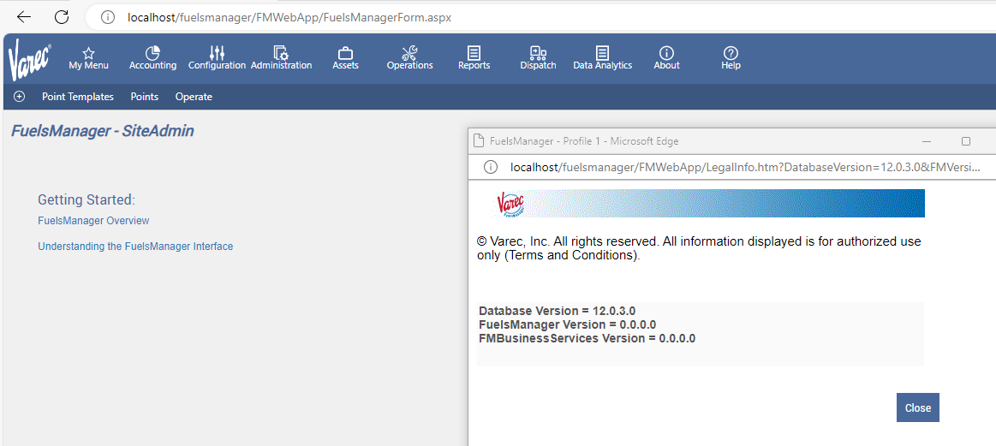

- SSIS Solution Version Number
The version number of the SSIS solution is maintained in the SSIS Project Description field. Once the project is deployed the version number can be viewed from the Integration Services Catalogue in SSMS. Right-click the SSIS project under the catalogue and select Properties. The version number appears in the Description field.

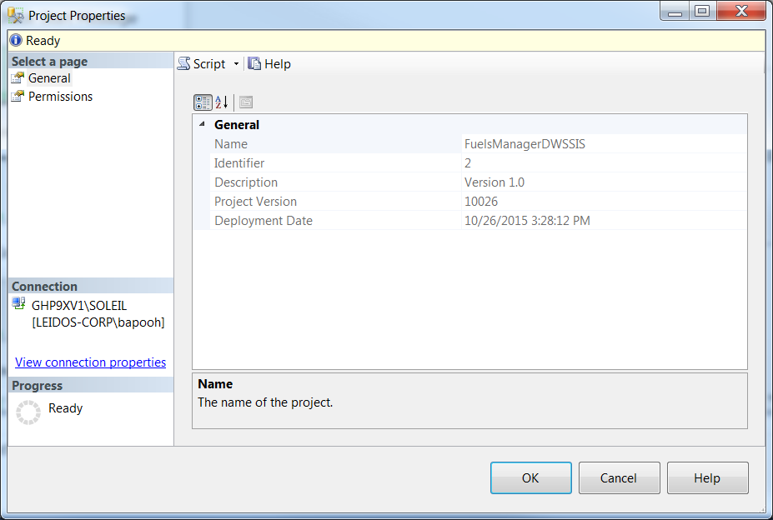

- SSAS OLAP Solution Version Number
The version number of the SSAS solution is maintained in the OLAP Cube Description field. Once the solution is deployed, the version number can be viewed from the SSMS for analysis Services. From Object Explorer, expand the Cubes node under the specific SSAS database. Right-click on the OLAP Cube under the Cubes node and select Properties. The version number appears in the Description field.

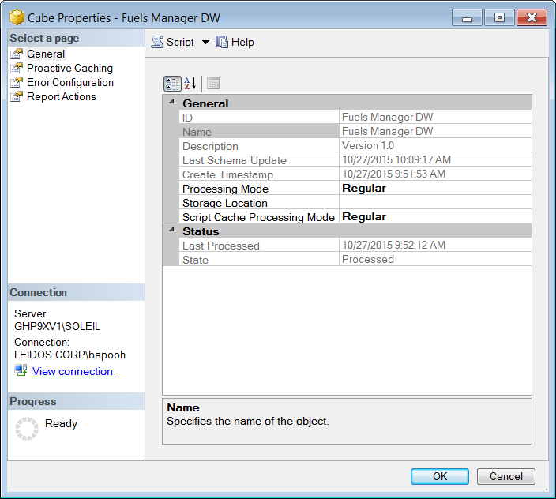

- Data Warehouse Database Version Number
The version number of the Data Warehouse database is maintained in table dbo.tblSystemSettings, in the DBVersion field.

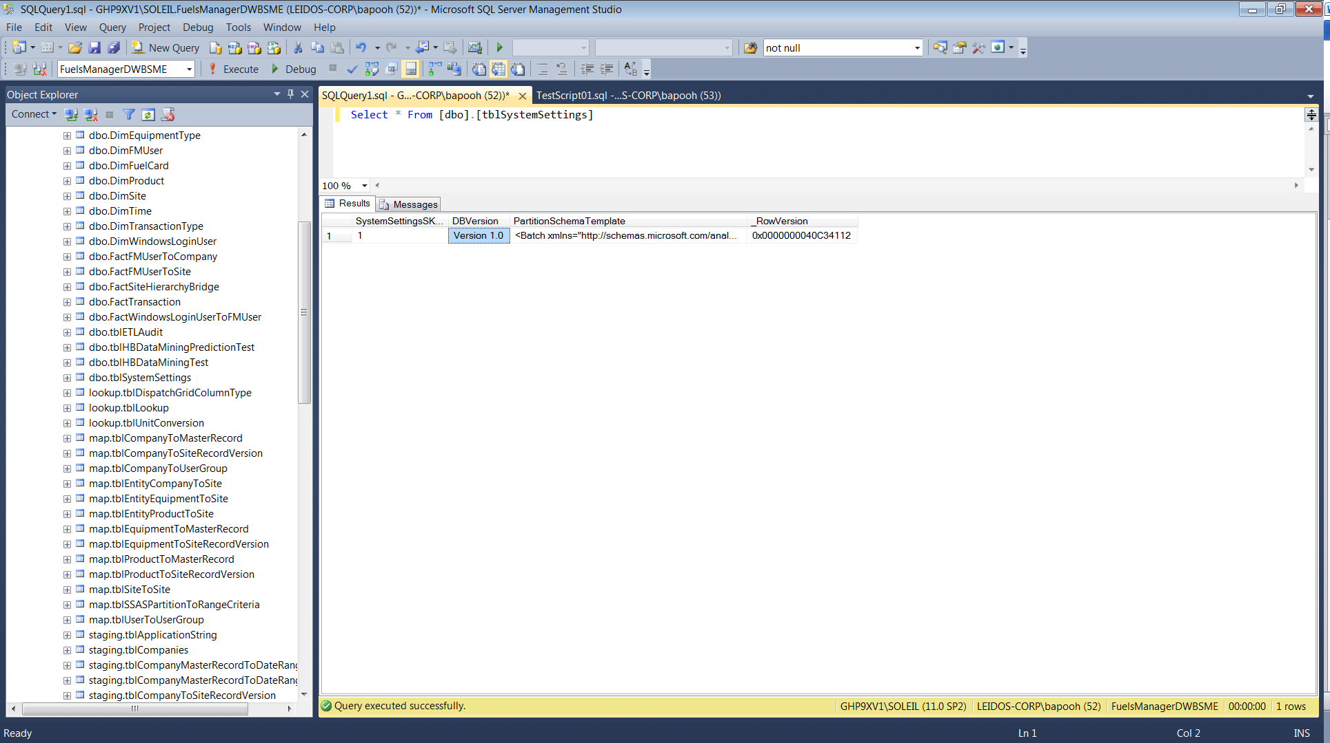

- Product Version Number
This is the version number of the overall Data Warehouse product itself. Unlike the other version numbers, it is directly accessible to the end-user as a dimension attribute, SystemInfo.DataWarehouseVersion.
E.g. from Excel:
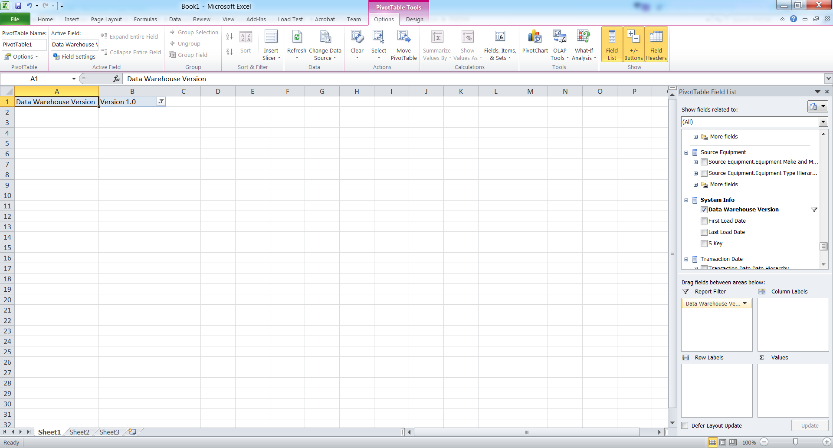

- SSRS OLAP Dashboards
Each of the SSRS OLAP .rdl files contains a comment section block at the beginning of the file that specifies the version number. From the SSRS server, download each .rdl file, then open each file in a text editor, and verify the version number in the comment block.
